25 Aug 2024

Praise to the Lord, the Almighty

D G Bm G

[Verse 1]
D
Praise to the Lord
F#m G A7 D
The Al-mighty, the King of cre – a - tion
D
O my soul, praise Him for
F#m G A7 D
He is thy health and sal – va - tion
D G
All ye who hear
D G A
Now to His temple draw near
A7 Bm G D
Praise Him in glad ador – a - tion

D G Bm G

[Verse 2]
D
Praise to the Lord
F#m G A7 D
Who o’er all things so wondrously reign-eth
D
Shelters thee un-der His
F#m G A7 D
Wings, yea, so gent-ly sus-tain-eth
D G
Hast thou not seen
D G A
How Thy de-sires e’er have been
A7 Bm G D
Granted in what He or – dain - eth

D G Bm G

[Verse 3]
D
Praise to the Lord
F#m G A7 D
Who doth pros-per thy work and de-fend thee
D
Surely His good-ness and
F#m G A7 D
Mercy here daily at-tend thee
D G
Ponder a-new
D G A
What the Al-mighty can do
A7 Bm G D
If with His love He be-friend thee

D G Bm G

[Verse 4]
Bm
Praise to the Lord
F#m G A7 D
O let all that is in me a-dore Him
Bm
All that hath life and breath
F#m G A7 D
Come now with praises be-fore Him
D G
Let the A-men
D G A
Sound from His people again
A7 Bm G D
Gladly forever a-dore Him

Lord I Give You My Heart

[Verse]
G Em C G D
This is my desire to honour You
Em G F C D
Lord with all my heart I worship You
G Em
All I have within me
C G D
I give You praise
Em G F C D
And all that I adore is in You

[Chorus]
G D
Lord I give You my heart
Am
I give You my soul
C D G
I live for You alone
G D
Every breath that I take
Am
Every moment I'm awake
C D G D
Lord have Your way in me

[Verse]
G Em C G D
This is my desire to honour You
Em G F C D
Lord with all my heart I worship You
G Em
All I have within me
C G D
I give You praise
Em G F C D
And all that I adore is in You

C G C G

[Bridge]
C
And I will live
Em C D G
And I will live for you
C
And I will live
Em C D
And I will live for you

[Chorus]
G D
Lord I give You my heart
Am
I give You my soul
C D G
I live for You alone
G D
Every breath that I take
Am
Every moment I'm awake
C D G D
Lord have Your way in me

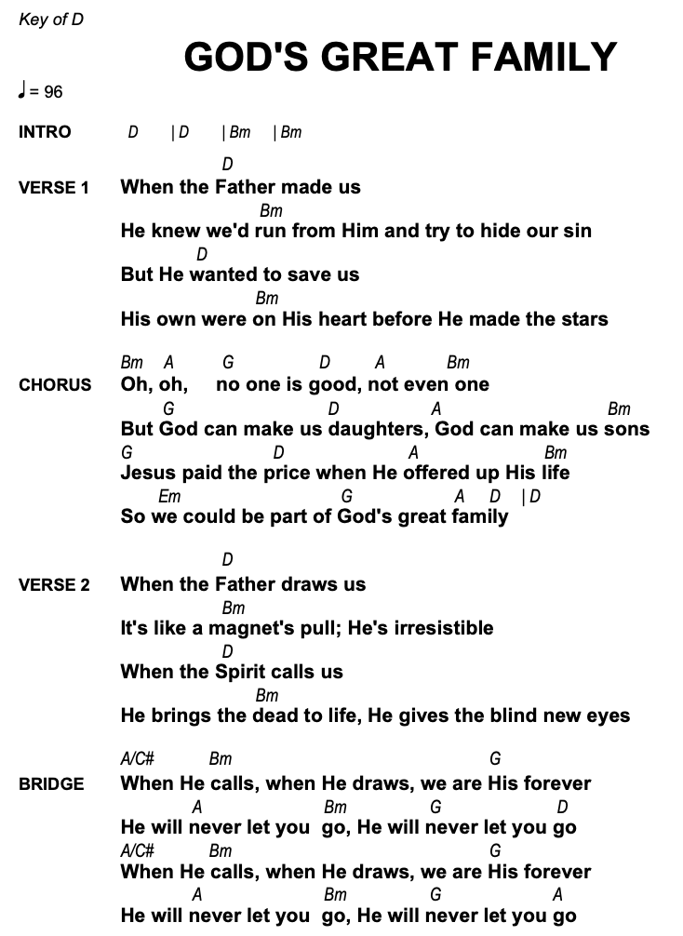
I have Decided to follow Jesus

Stanza 1
G
I have decided to follow Jesus.
C G
I have decided to follow Jesus.
Em
I have decided to follow Jesus.
G D G
No turning back, no turning back.

Stanza 2
G
The world behind me, the cross before me
C G
The world behind me, the cross before me
Em
The world behind me, the cross before me
G D G
No turning back, no turning back.

Stanza 3
G
Though none go with me, still I will follow.
C G
Though none go with me, still I will follow.
G Em
Though none go with me, still I will follow.
G D G
No turning back, no turning back.

All I Have Is Christ

[Intro]
||: Am C/E | F C/E | F G | C :|| | C x2

[Verse 1]
G Am
I once was lost in darkest night
F Am
Yet thought I knew the way
Dm F
The sin that promised joy and life
G C
Had led me to the grave
C/E F
I had no hope that You would own
Dm Am
A rebel to Your will
C/E F
And if You had not loved me first
Am G
I would refuse You still

[Instrumental]
||: Am C/E | F C/E | F G | C :|| | C

[Verse 2]
G Am
But as I ran my hell-bound race
F Am
Indifferent to the cost
Dm F
You looked upon my helpless state
G C
And led me to the cross
C/E F
And I beheld God's love displayed
Dm Am
You suffered in my place
C/E F
You bore the wrath reserved for me
Am G
Now all I know is grace

[Chorus] (Soft, build on 2nd)
F C G Am
Hallelujah! All I have is Christ
F Am G C
Hallelujah! Jesus is my life x2

[Intro]
||: Am C/E | F C/E | F G | C :|| | C x2

[Verse 3] (Soft)
G Am
Now, Lord, I would be Yours alone
F C
And live so all might see
Dm F
The strength to follow Your commands
G C
Could never come from me
C
Oh Father, use my ransomed life

In any way You choose
Am F
And let my song forever be
Am G
My only boast is You

[Chorus] Loud
F C G Am
Hallelujah! All I have is Christ
F Am G C
Hallelujah! Jesus is my life x2

[Outtro]
||: Am C/E | F C/E | F G | C :|| | C x2

